**STATE SPACE REPRESENTATİON OF THE PMSM AND LOAD**

Rearranged by S.Ozkucuk from “Permanent Magnet Synchronous Motor with Linear Quadratic Speed Controller, Wen-Jun Xu”

**Mathematical Model of PMSM**

The equations that govern the electric dynamics of PMSM are expressed in the rotor reference frame (qd frame) as follows:

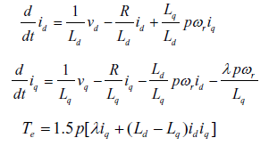 

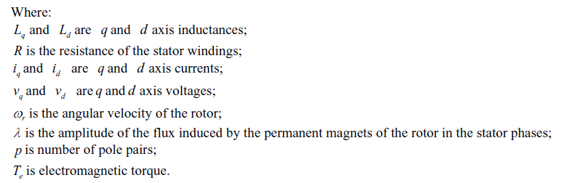

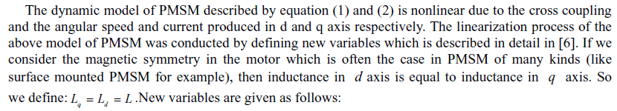

 



 

 



**Mechanical Model of PMSM**



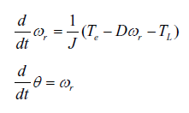 

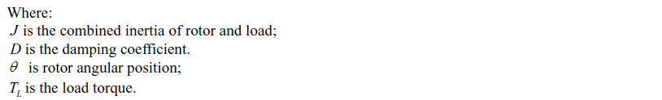



** **

** **

** **

** **

**Continuous State-Space Model of PMSM**

** **

 